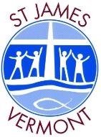
2021 St James
Student Code of Conduct Agreement

- Respecting all people, property and the school environment
- Following Directions Immediately
- Listening to Others
- Being Kind
- Looking After One Another
- Trying My Best & Don’t Give Up
- Making Safe Choices
- Speaking Up When I Feel Unsafe or Uncomfortable

As a student of St James I agree to the following behaviours and understand that if I do not follow the student code of conduct there will be consequences.

Student Name: _________________________________
Student’s Signature: ______________________________
Date: ____________

As a parent of a child who attends St James I agree to support my child in upholding the behaviours described in the code of conduct and understand that if my child breaches the code of conduct there will be consequences.

Parent Name: __________________________________
Parent’s Signature: _______________________________
Date: ____________

